

AP® Physics C
1998 Free response Questions

The materials included in these files are intended for use by AP teachers for course and exam preparation in the classroom; permission for any other use must be sought from the Advanced Placement Program®. Teachers may reproduce them, in whole or in part, in limited quantities, for face-to-face teaching purposes but may not mass distribute the materials, electronically or otherwise. These materials and any copies made of them may not be resold, and the copyright notices must be retained as they appear here. This permission does not apply to any third-party copyrights contained herein.

These materials were produced by Educational Testing Service® (ETS®), which develops and administers the examinations of the Advanced Placement
Program for the College Board. The College Board and Educational Testing Service (ETS) are dedicated to the principle of equal opportunity, and their
programs, services, and employment policies are guided by that principle.

The College Board is a national nonprofit membership association dedicated to preparing, inspiring, and connecting students to college and opportunity.
Founded in 1900, the association is composed of more than 4,200 schools, colleges, universities, and other educational organizations. Each year, the
College Board serves over three million students and their parents, 22,000 high schools, and 3,500 colleges, through major programs and services in
college admission, guidance, assessment, financial aid, enrollment, and teaching and learning. Among its best-known programs are the SAT®, the
PSAT/NMSQT®, and the Advanced Placement Program® (AP®). The College Board is committed to the principles of equity and
excellence, and that commitment is embodied in all of its programs, services, activities, and concerns.

APIEL is a trademark owned by the College Entrance Examination Board. PSAT/NMSQT is a registered trademark jointly owned by the College Entrance Examination Board and the National Merit Scholarship Corporation. Educational Testing Service and ETS are registered trademarks of Educational Testing Service.
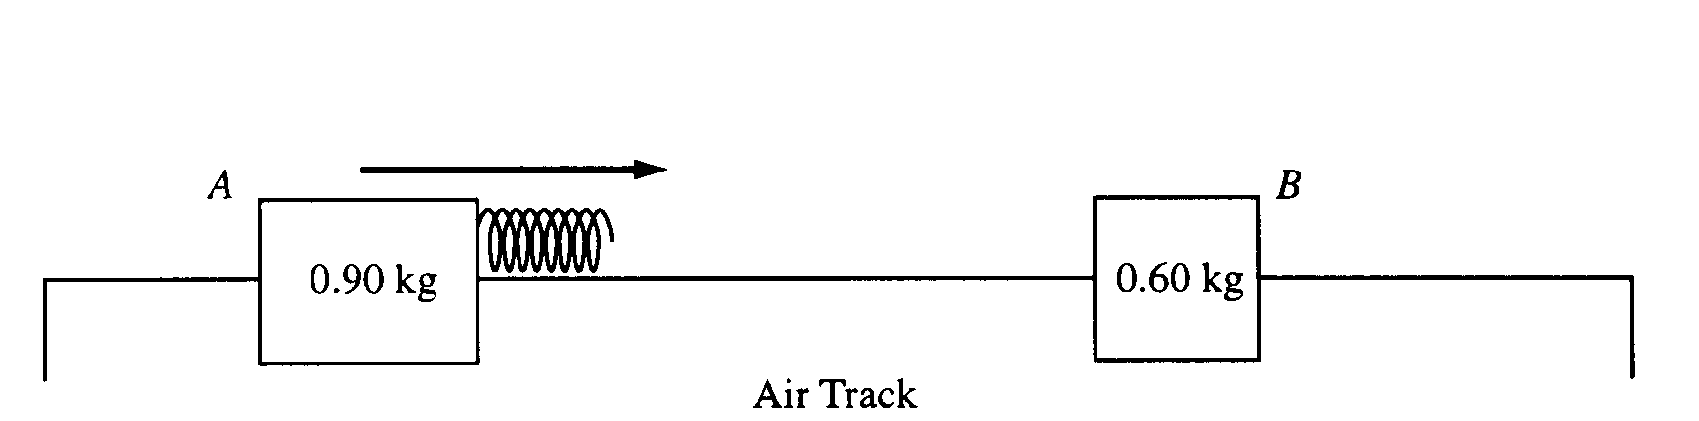

1998M1. Two gliders move freely on an air track with negligible friction, as shown above. Glider A has a mass of 0.90 kg and glider B has a mass of 0.60 kg. Initially, glider A moves toward glider B, which is at rest. A spring of negligible mass is attached to the right side of glider A. Strobe photography is used to record successive positions of glider A at 0.10 s intervals over a total time of 2.00 s, during which time it collides with glider B.

The following diagram represents the data for the motion of glider A. Positions of glider A at the end of each 0.10s interval are indicated by the symbol A against a metric ruler. The total elapsed time t after each 0.50 s is also indicated.
a. Determine the average speed of glider A for the following time intervals.
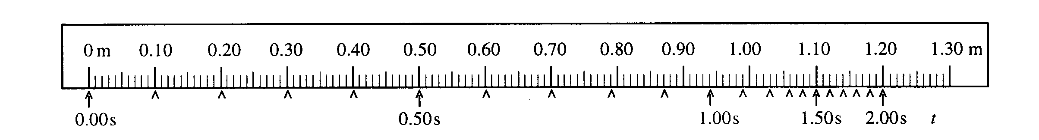
i. 0.L0 s to 0.30 s ii. 0.90 s to 1.10 s iii. 1.70 s to 1.90 s
b. On the axes below, sketch a graph, consistent with the data above, of the speed of glider A as a function of time t for the 2.00 s interval.
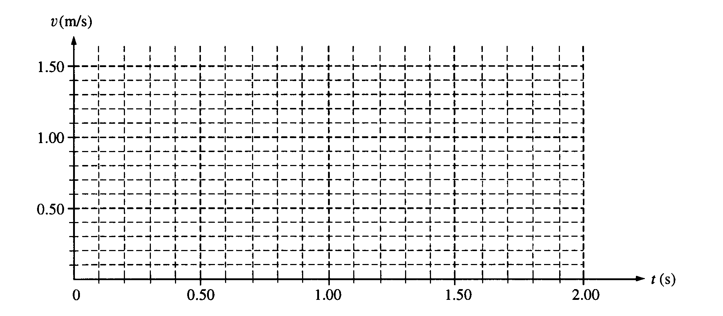

c. i. Use the data to calculate the speed of glider B immediately after it separates from the spring.
ii. On the axes below, sketch a graph of the speed of glider B as a function of time t.
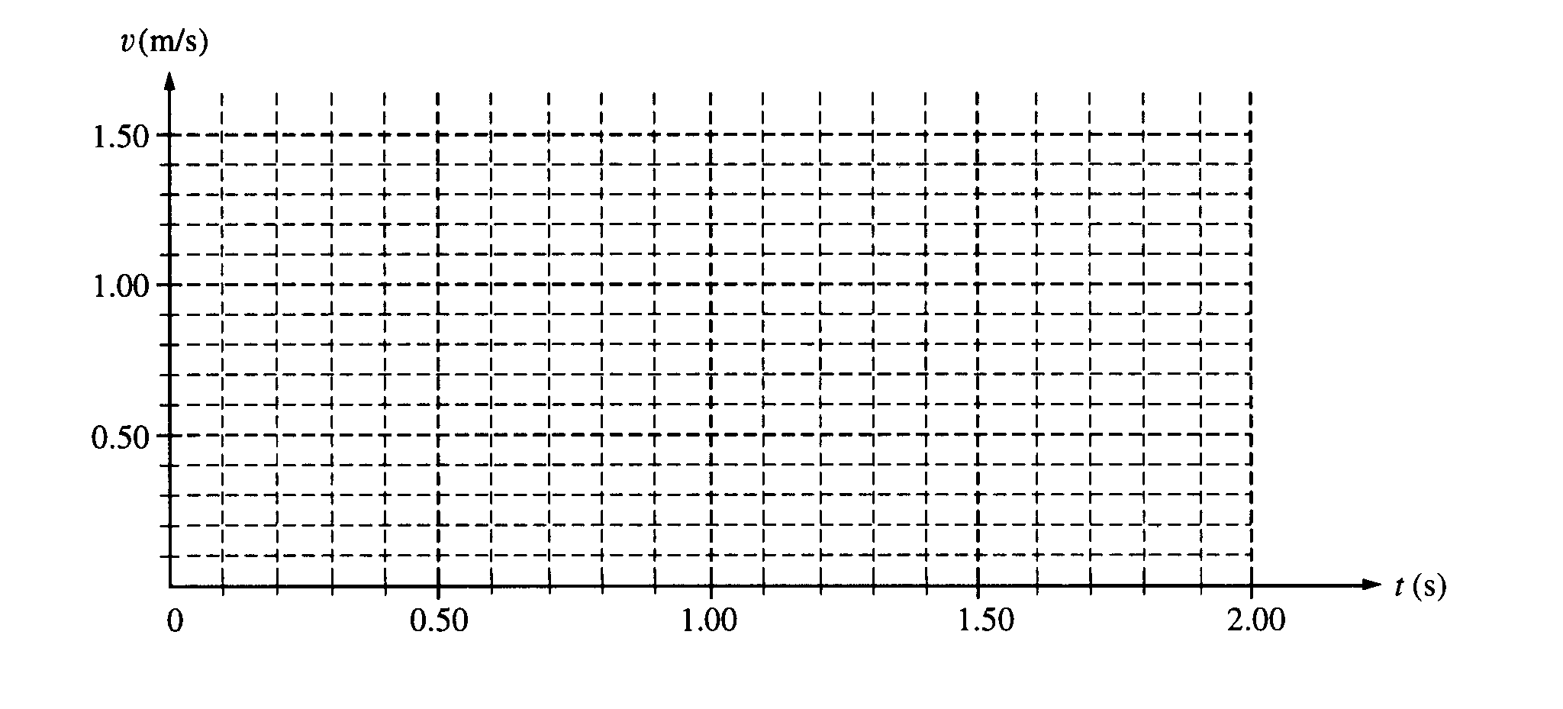
A graph of the total kinetic energy K for the two-glider system over the 2.00 s interval has the following shape. K_{o} is the total kinetic energy of the system at time t = 0.
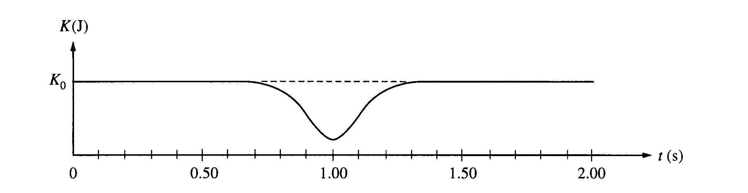

d. i. Is the collision elastic? Justify your answer.

ii. Briefly explain why there is a minimum in the kinetic energy curve at t = 1.00 s.
1998M2. A space shuttle astronaut in a circular orbit around the Earth has an assembly consisting of two small dense spheres, each of mass m, whose centers are connected by a rigid rod of length l and negligible mass. The astronaut also has a device that will launch a small lump of clay of mass m at speed v₀ . Express your answers in terms of m, v₀ l. and fundamental constants.
152
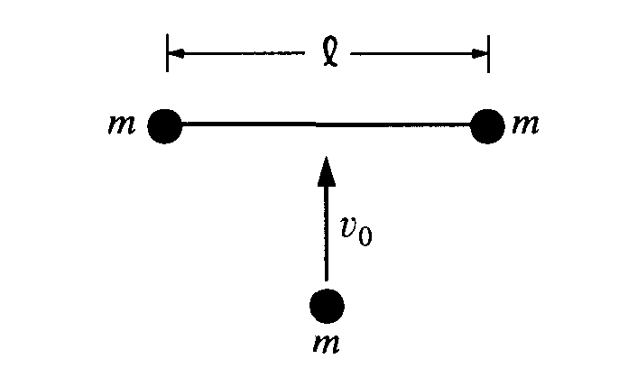
a. Initially, the assembly is "floating" freely at rest relative to the cabin, and the astronaut launches the clay lump so that it perpendicularly strikes and sticks to the midpoint of the rod, as shown above. i. Determine the total kinetic energy of the system (assembly and clay lump) after the collision. ii. Determine the change in kinetic energy as a result of the collision.
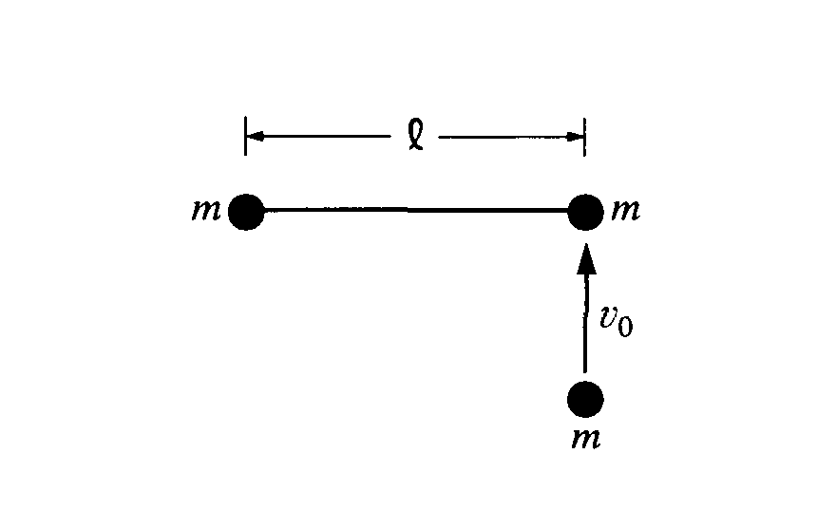

b. The assembly is brought to rest, the clay lump removed, and the experiment is repeated as shown above, with the clay lump striking perpendicular to the rod but this time sticking to one of the spheres of the assembly.
i. Determine the distance from the left end of the rod to the center of mass of the system (assembly and clay lump) immediately after the collision. (Assume that the radii of the spheres and clay lump are much smaller than the separation of the spheres.)

ii. On the figure above, indicate the direction of the motion of the center of mass immediately after the
collision.

iii. Determine the speed of the center of mass immediately after the collision.

iv. Determine the angular speed of the system (assembly and clay lump) immediately after the collision.

v. Determine the change in kinetic energy as a result of the collision.

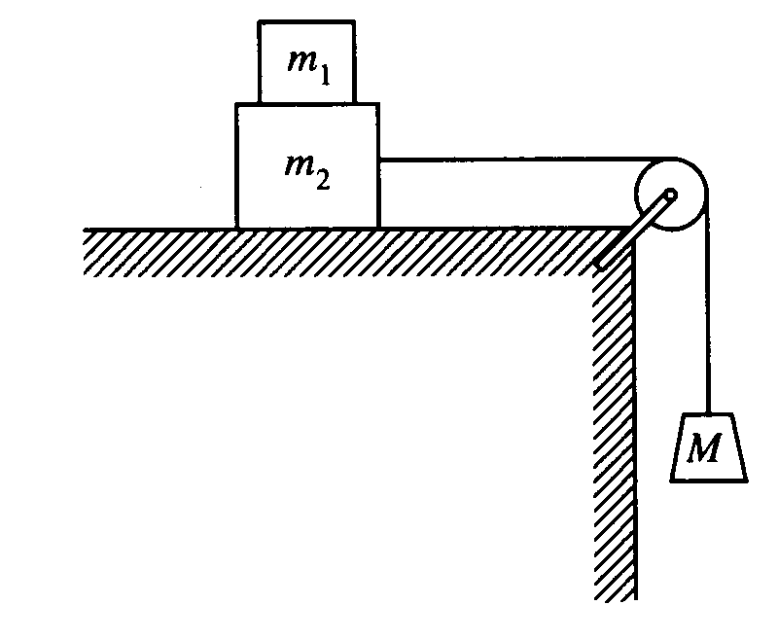
1998M3. Block 1 of mass m₁ is placed on block 2 of mass m₂ which is then placed on a table. A string connecting block 2 to a hanging mass M passes over a pulley attached to one end of the table, as shown above. The mass and friction of the pulley are negligible. The coefficients of friction between blocks 1 and 2 and between block 2 and the tabletop are nonzero and are given in the following table.
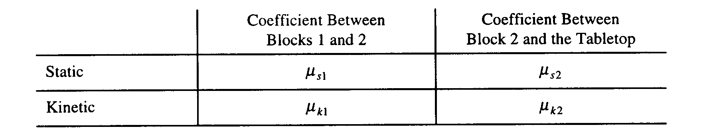
Express your answers in terms of the masses, coefficients of friction, and g, the acceleration due to gravity.
a. Suppose that the value of M is small enough that the blocks remain at rest when released. For each of the following forces, determine the magnitude of the force and draw a vector on the block provided to indicate the direction of the force if it is nonzero.
i. The normal force N₁ exerted on block 1 by block 2
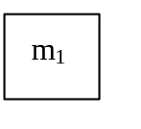
ii. The friction force f₁ exerted on block 1 by block 2
iii. The force T exerted on block 2 by the string
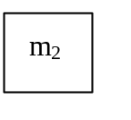
iv. The normal force N₂ exerted on block 2 by the tabletop
v. The friction force f₂ exerted on block 2 by the tabletop
b. Determine the largest value of M for which the blocks can remain at rest.
c. Now suppose that M is large enough that the hanging block descends when the blocks are released. Assume that blocks 1 and 2 are moving as a unit (no slippage). Determine the magnitude a of their acceleration.

d. Now suppose that M is large enough that as the hanging block descends, block 1 is slipping on block 2. Determine each of the following.
i. The magnitude a₁ of the acceleration of block 1
ii. The magnitude a₂ of the acceleration of block 2
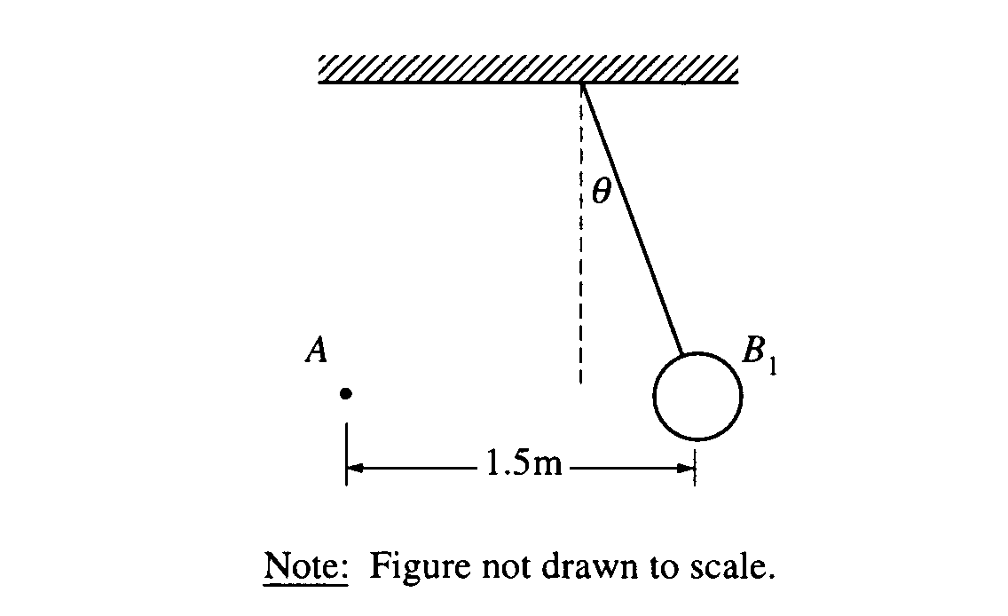
1998E1. The small sphere A in the diagram above has a charge of 120 μ C. The large sphere B₁ is a thin shell of nonconducting material with a net charge that is uniformly distributed over its surface. Sphere B₁ has a mass of 0.025 kg, a radius of 0.05 m, and is suspended from an uncharged, nonconducting thread. Sphere B₁ is in equilibrium when the thread makes an angleθ = 20° with the vertical. The centers of the spheres are at the same vertical height and are a horizontal distance of 1.5 m apart, as shown.
a. Calculate the charge on sphere B₁.

b. Suppose that sphere B₁ is replaced by a second suspended sphere B₂ that has the same mass, radius, and charge, but that is conducting. Equilibrium is again established when sphere A is 1.5 m from sphere B₂ and their centers are at the same vertical height. State whether the equilibrium angle θ₂ will be less than, equal to, or greater than 20°. Justify your answer.

The sphere B₂ is now replaced by a very long, horizontal, nonconducting tube, as shown in the top view below. The tube is hollow with thin walls of radius R = 0.20 m and a uniform positive charge per unit length of
λ = +0.10 μC/m.
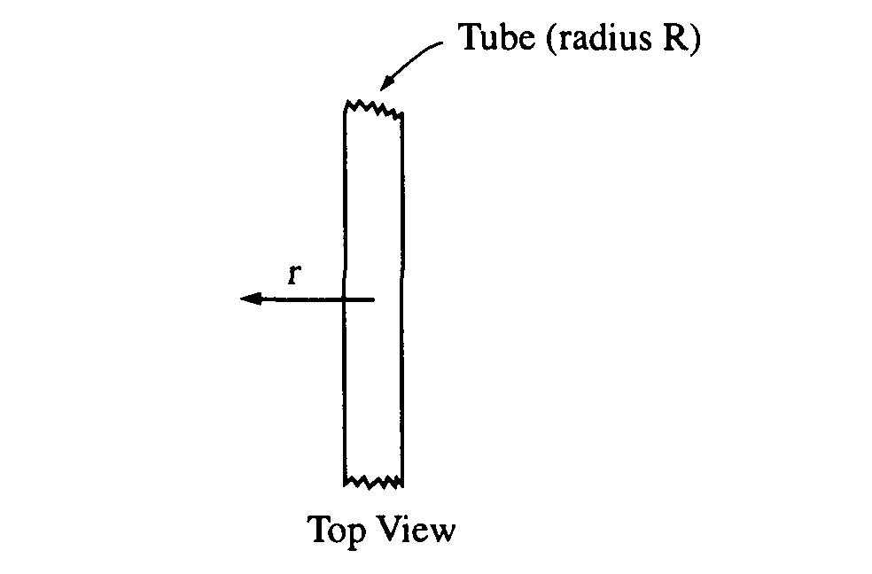
c. Use Gauss's law to show that the electric field at a perpendicular distance r from the tube is given by the expression E = (1.8 x 10³)/r N/C, where r>R and r is in meters.
d. The small sphere A with charge 120 μC is now brought into the vicinity of the tube and is held at a distance of r = 1.5 m from the center of the tube. Calculate the repulsive force that the tube exerts on the sphere.
e. Calculate the work done against the electrostatic repulsion to move sphere A toward the tube from a distance
r = 1.5 m to a distance r = 0.3 m from the tube.
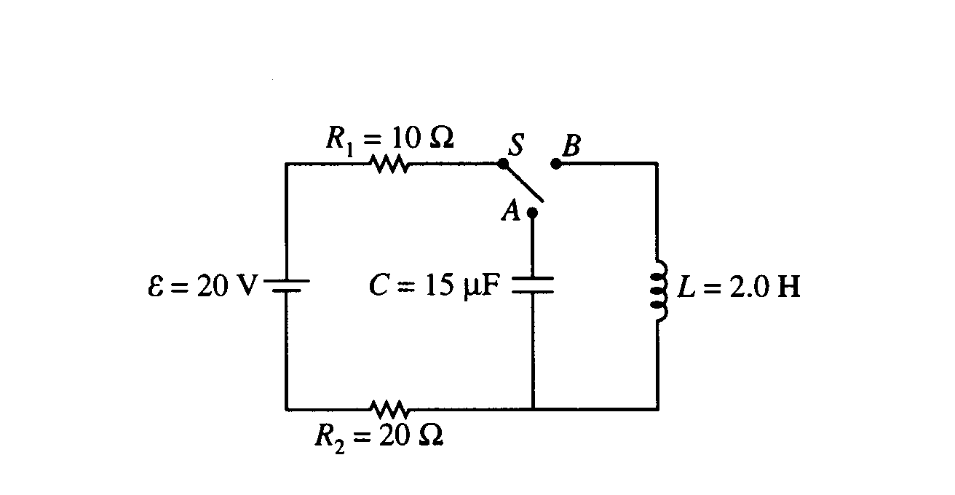
1998E2. In the circuit shown above, the switch S is initially in the open position shown, and the capacitor is uncharged. A voltmeter (not shown) is used to measure the correct potential difference across resistor R₁.
a. On the circuit diagram above, draw the voltmeter with the proper connections for correctly measuring the potential difference across resistor R₁.
b. At time t = 0, the switch is moved to position A. Determine the voltmeter reading for the time immediately after t = 0.
c. After a long time, a measurement of potential difference across R₁ is again taken. Determine for this later time each of the following.
i. The voltmeter reading
ii. The charge on the capacitor
d. At a still later time t = T, the switch S is moved to position B. Determine the voltmeter reading for the time immediately after t = T.
e. A long time after t = T, the current in R₁ reaches a constant final value I_{f}.
i. Determine I_{f}.
ii. Determine the final energy stored in the inductor.
f. Write, but do not solve, a differential equation for the current in resistor R₁ as a function of time t after the switch is moved to position B.
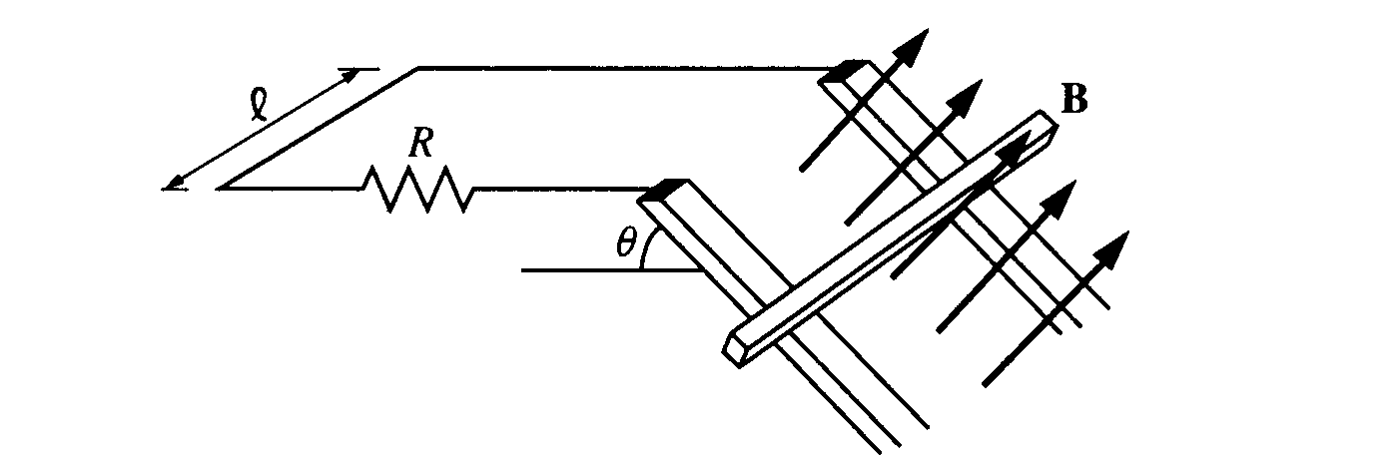
1998E3. A conducting bar of mass m is placed on two long conducting rails a distance l apart. The rails are inclined at an angle θ with respect to the horizontal, as shown above, and the bar is able to slide on the rails with negligible friction. The bar and rails are in a uniform and constant magnetic field of magnitude B oriented perpendicular to the incline. A resistor of resistance R connects the upper ends of the rails and completes the circuit as shown. The bar is released from rest at the top of the incline. Express your answers to parts (a) through (d) in terms of m, l, θ, B, R, and g.
a. Determine the current in the circuit when the bar has reached a constant final speed.
b. Determine the constant final speed of the bar.
c. Determine the rate at which energy is being dissipated in the circuit when the bar has reached its constant final speed.
d. Express the speed of the bar as a function of time t from the time it is released at t = 0.
e. Suppose that the experiment is performed again, this time with a second identical resistor connecting the rails at the bottom of the incline. Will this affect the final speed attained by the bar, and if so, how? Justify your answer.

